Week 4 – Compilation of Findings & Final Presentation(Team Report)
Internship: Data Visualization Associate (Excelerate Virtual Internship)
Week: 4 – Dashboard Refinement, Insights Extraction & Final Presentation
Team Contribution: Joint report covering dashboard analysis, key insights, and preparation of the final presentation for senior management.

Introduction
Following the successful completion of Week 3, where the team developed a structured mapping table, identified key KPIs, and designed a detailed wireframe to guide dashboard creation, Week 4 focused on refining the fully developed dashboard and preparing for the final presentation. The emphasis shifted from building to interpreting, with the goal of translating raw data into actionable insights.
This stage required not only ensuring that the dashboard was visually clear, interactive, and business-ready but also demonstrating our ability to communicate findings effectively. By analyzing the dashboard outputs, the team compiled insights, identified trends, and extracted meaningful patterns that highlight the value of the selected KPIs. These findings were then structured into a professional presentation tailored for senior management.

Objectives
- Analyze Dashboard Outputs: Extract trends, correlations, and insights from key metrics.
- Structure Professional Presentation: Clearly communicate the methodology, process, and impact of findings.
- Develop a Slide Deck: Create a visually compelling and data-driven presentation highlighting KPIs, trends, and business implications.
- Curate Final Dashboard: Refine and optimize for clarity, usability, and impactful storytelling.

Activities of Week-4
- Insight Extraction:
- Reviewing KPIs (applications, enrollment trends, learner engagement, demographic distributions).
- Identifying key trends and anomalies across opportunities, cohorts, and user demographics.
- Compiling actionable insights to support data-driven decision-making.
- Dashboard Refinement:
- Ensuring filters, drill-downs, and chart placements enhanced user experience.
- Validating consistency of mapping table logic and business rules.
- Adjusting visualization formats to emphasize critical KPIs.
- Presentation Development:
- Designing a slide deck highlighting methodology, data pipeline (Weeks 1–3), and (week-4) dashboard outputs.
- Structuring findings into context → insight → business implication flow.
- Incorporating visuals from the dashboard to strengthen storytelling.

Expected Deliverables by the End of Week 4
- Final Dashboard Link: Refined and optimized for clear insights and interactivity.
- Comprehensive Report: Summarizing activities of Week-4, documentation of each details.
- Team Presentation : Professional slides highlighting of all week’s activities including KPIs, insights, and business implications for senior management.Delivery of data-driven findings, showcasing the ability to interpret and communicate insights effectively.
Connection To Looker Studio:
Step-1: clicking on ‘Create’ button & then clicking on ‘Report’
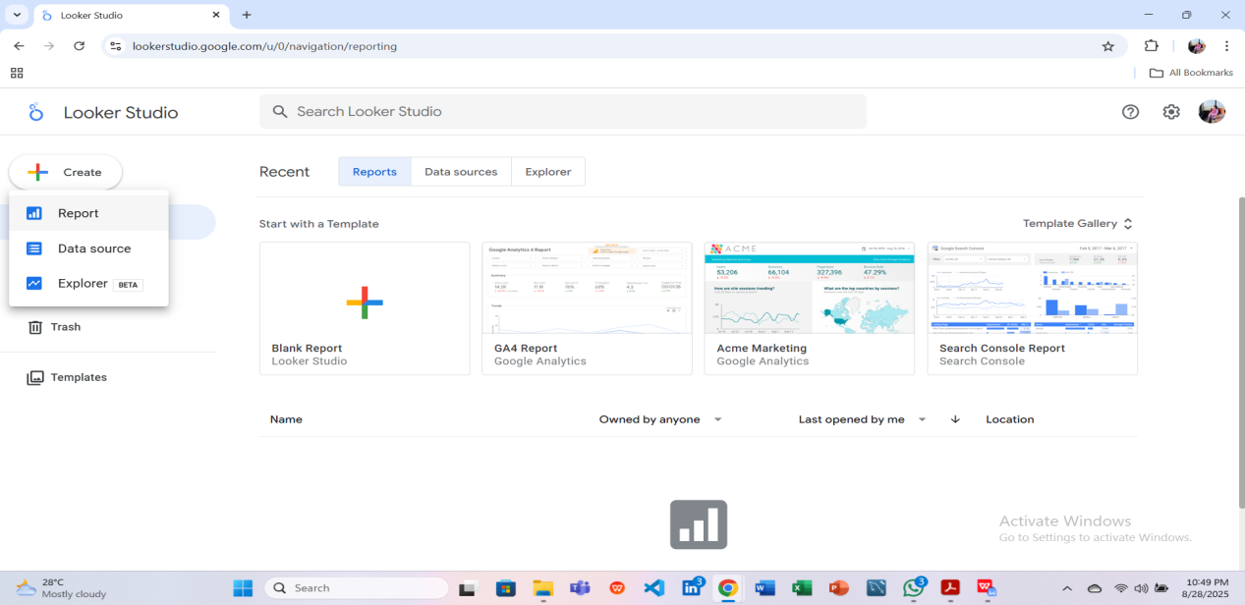
Step-2: Typed Upload in ‘search’ button then clicking on ‘CSV File Upload’
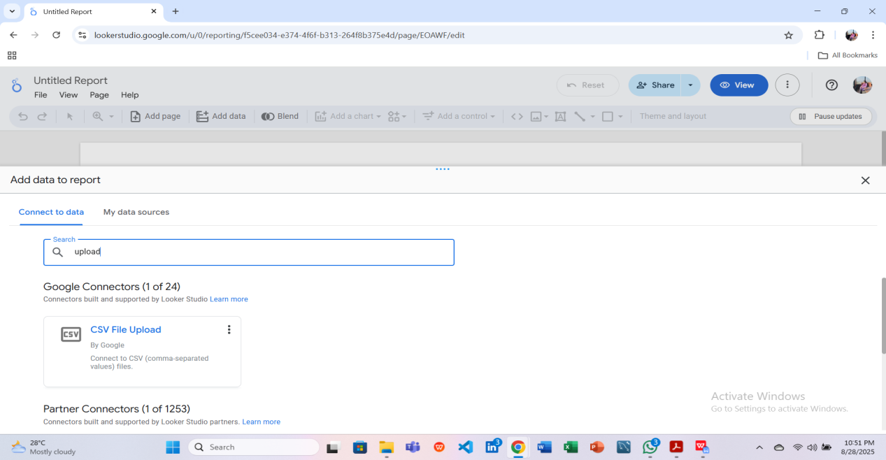
Step-3: Uploaded “Cleaned_Master_Table.csv” file
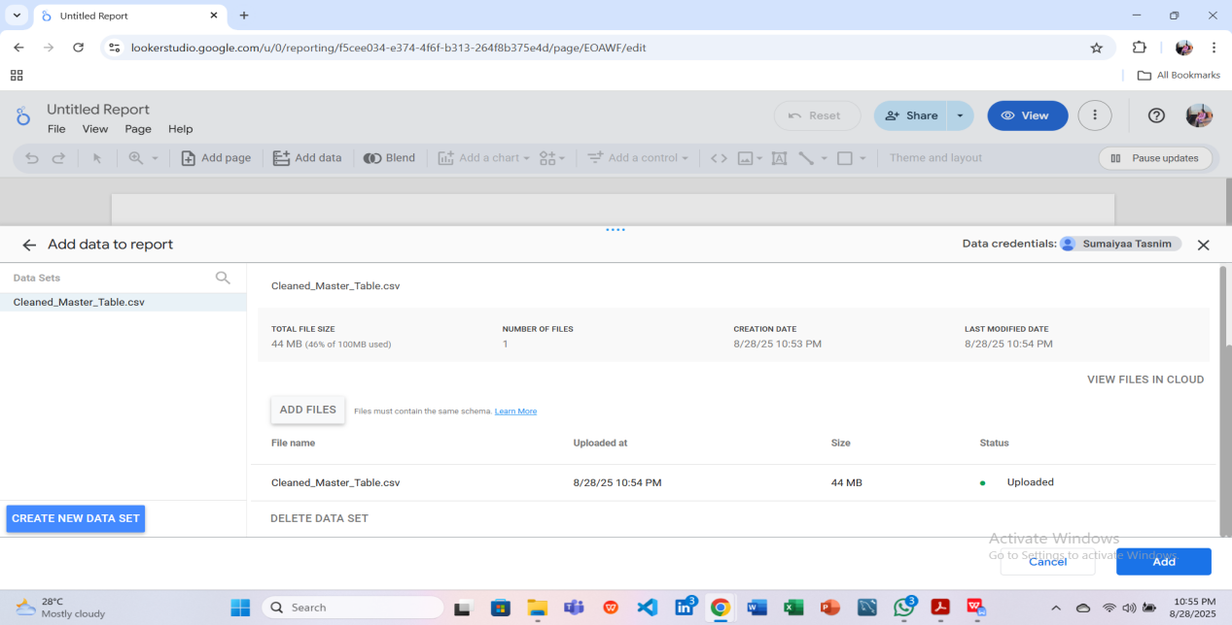
Step-4: clicked ‘ADD’ button & Now clicking on ‘ADD TO REPORT’
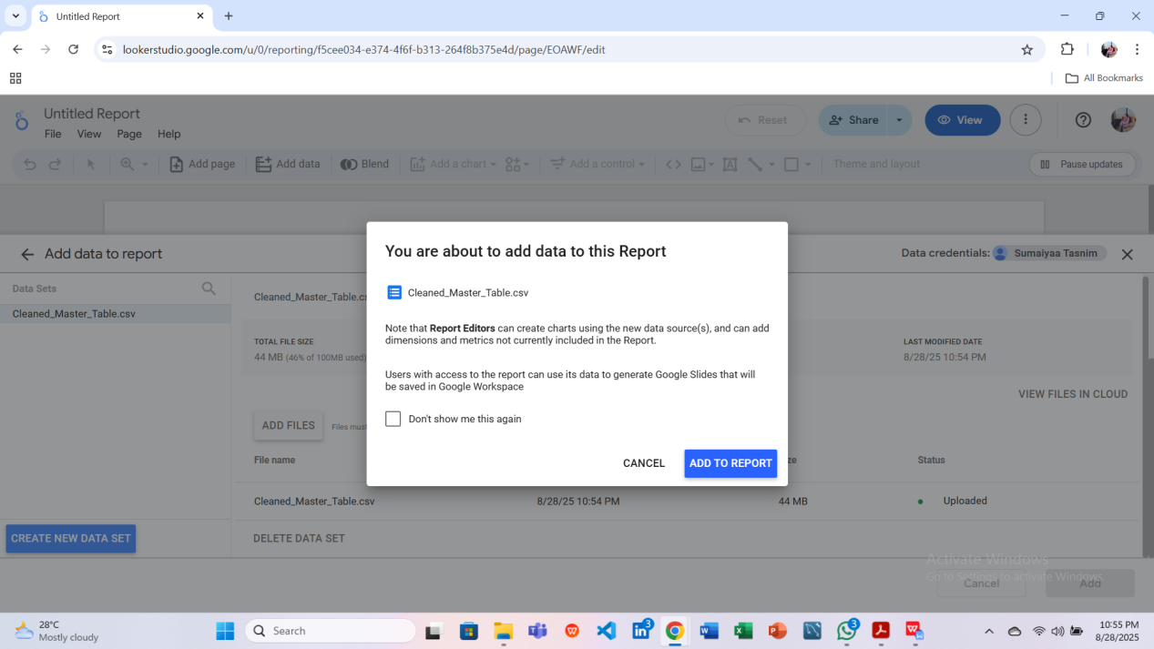
Step-5: Finally Imported Dataset of Cleaned_Master_Table & Connected to Looker studio
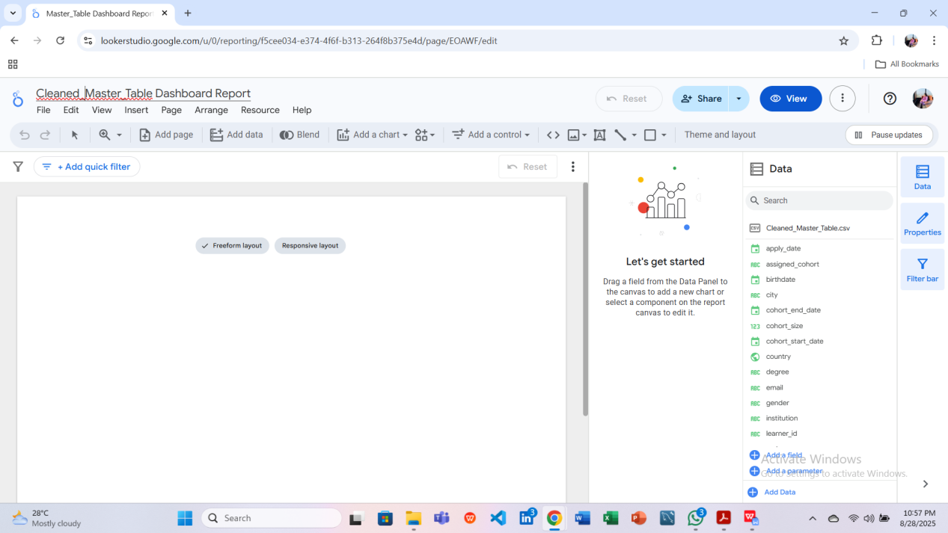

Dashboard of Master_Table:
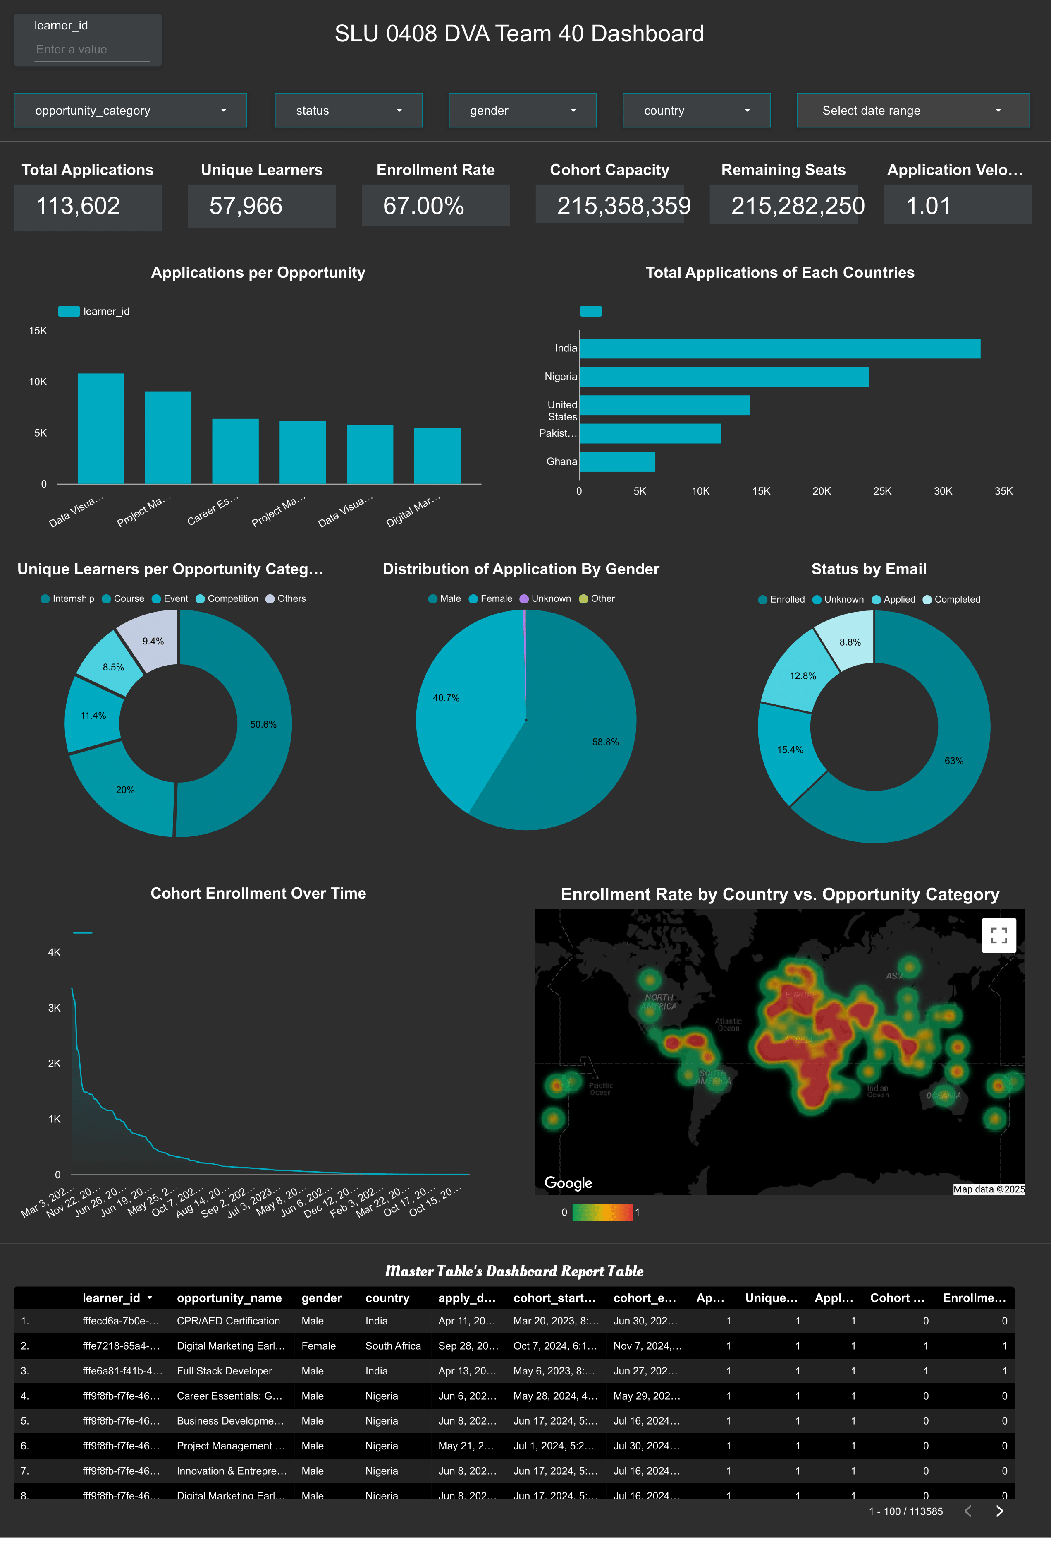Dashboard Report Link to View Access in Looker Studio : https://lookerstudio.google.com/reporting/f5cee034-e374-4f6f-b313-264f8b375e4d
Details of Key Performance Indicators (KPIs) & Selected Relevent Metrics:
(Followed Mapping Table)

KPI Name | Dimension (Formula) | Why Added
Total Applications | COUNT(*) | To measure overall application volume across all opportunities.
Unique Learners | COUNT_DISTINCT(learner_id) | To track how many individual learners are applying, avoiding duplicates.
Enrollment Rate | SUM(CASE WHEN status = 'Enrolled' THEN 1 ELSE 0 END) / COUNT(apply_date) | To evaluate the effectiveness of applications converting into enrollments.
Cohort Capacity | SUM(cohort_size) | To understand the total seats available for each cohort.
Remaining Seats | SUM(cohort_size) - SUM(CASE WHEN status = 'Enrolled' THEN 1 ELSE 0 END) | To monitor available capacity and plan for potential overflows.
Application Velocity | COUNT(*) / COUNT_DISTINCT(apply_date) | To measure the speed at which applications are coming in, useful for trend analysis.

Implementation Of Filters, Drill-Downs & Interactive Elements with Importance:

(Filters)
Filter | Suitable Filter Type | Notes / Usage
Opportunity Category | Dropdown / Multi-select | Allows filtering charts and KPIs by one or multiple opportunity categories.
Status | Dropdown / Single-select | Quickly isolate learners by their application status (Enrolled, Applied, etc.).
Gender | Dropdown / Single-select | Analyze demographic splits in charts like pie or bar charts.
Country | Dropdown / Multi-select | Filter data geographically for applications, enrollments, and enrollment rate.
Date Range (cohort_start_date → cohort_end_date) | Date Range / Slider | Analyze trends over specific cohorts, enrollment rate, and application velocity.
learner_id | Search Control (Equals) | Lookup a specific learner by ID → useful for user-level drill-down or debugging.

(Drill-Down Controls)
Dimension / Metric | Formula | User Interaction Features
learner_id (Dimension) | — | Can be used for drill-through to learner-level detail, search, or filtering.
opportunity_name (Dimension) | — | Supports drill-down (Opportunity Category → Opportunity Name), and filtering by program.
gender (Dimension) | — | Enables demographic filter or grouping (e.g., Male/Female/Other split).
country (Dimension) | — | Allows geographic drill-down and cross-filtering (row chart, heatmap).
apply_date (Dimension) | — | Used for time-based filtering, sorting, and trend exploration.
cohort_start_date (Dimension) | — | Allows filtering or grouping by cohort start → trend analysis over time.
cohort_end_date (Dimension) | — | Enables filtering/grouping by cohort completion → useful for capacity planning.
Applied (Metric) | COUNT(learner_id) | Allows sorting by application volume, comparison across dimensions.
Unique Learners (Metric) | COUNT_DISTINCT(learner_id) | Ensures drill-down to unique learners, prevents duplicate counts in interactions.
Applies per Country (Metric) | COUNT(apply_date) | Supports cross-filtering with Country dimension → easy country-level comparisons.
Cohort Enrollment (Metric) | SUM(CASE WHEN status = 'Enrolled' THEN 1 ELSE 0 END) | Enables trend and cohort performance analysis when combined with cohort dimensions.
Enrollment Rate (Metric) | SUM(CASE WHEN status='Enrolled' THEN 1 ELSE 0 END) / COUNT(apply_date) | Can be highlighted with conditional formatting → helps spot high/low conversion regions.

Every Chart’s Details & Importance:
Chart Type | Chart Name | Dimension(s) | Metric (with Formula) | Reason & Benefit
Bar Chart | Applications per Opportunity | opportunity_name | COUNT(learner_id) | Shows how many learners applied to each opportunity → identifies program demand.
Row Chart | Total Applications of Each Country | country | COUNT(apply_date) | Compares total applications across countries → useful for geographic insights.
Donut Chart | Unique Learners per Opportunity Category | opportunity_category | COUNT_DISTINCT(learner_id) | Highlights learner diversity across categories → avoids duplicate counts.
Pie Chart | Distribution of Application By Gender | gender | COUNT(apply_date) | Shows gender split of applicants → useful for demographic and diversity analysis.
Donut Chart | Status by Email | status | COUNT_DISTINCT(email) | Displays learner distribution by application status → helps track pipeline stage.
Line Chart | Cohort Enrollment Over Time | cohort_start_date | SUM(CASE WHEN status = 'Enrolled' THEN 1 ELSE 0 END) | Tracks enrollment trends over cohorts → helps measure growth & conversion trends.
Heatmap | Enrollment Rate by Country vs. Opportunity Category | country | SUM(CASE WHEN status='Enrolled' THEN 1 ELSE 0 END) / COUNT(apply_date) | Reveals efficiency of enrollment across geography & categories → spot strengths & gaps.

Review & Refining Visualizations:

Comparison of dashboard’s each value with the Output Values in PostgreSQL:

KPI(s) detection:

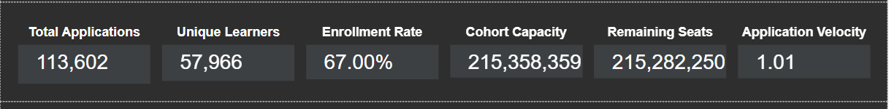

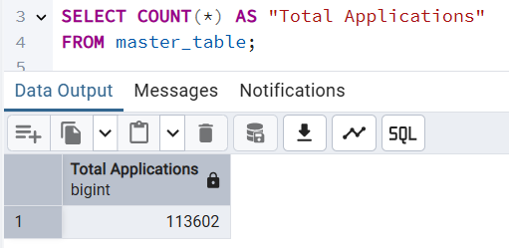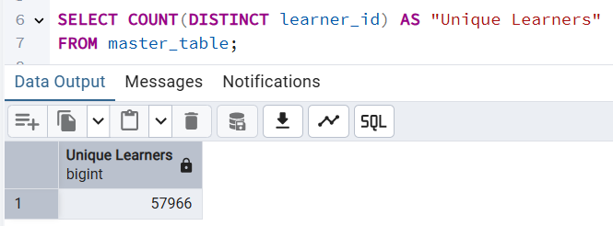

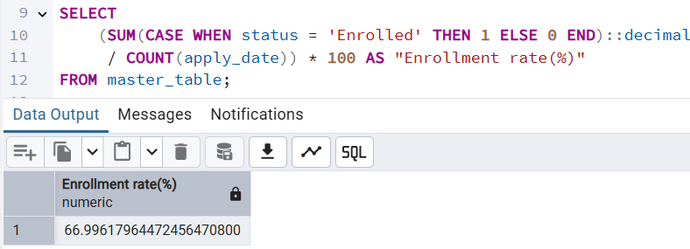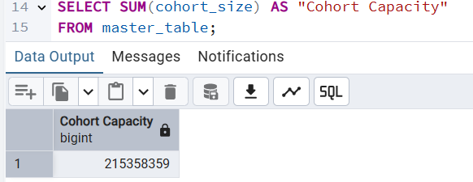

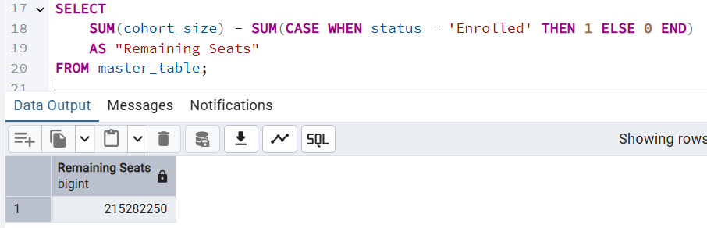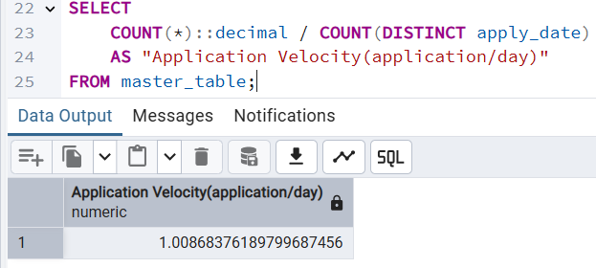

The output values obtained from PostgreSQL queries perfectly match the KPI values displayed on the dashboard.

Chart(s) Detection:
Bar Chart Values (Applications per Opportunity):
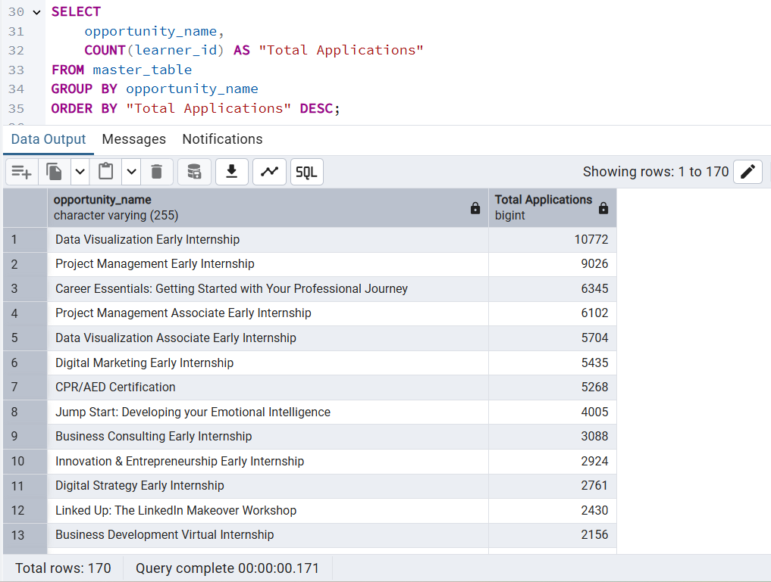

Row Chart Values (Total Applications of Each Country) & Donut Chart Values (Unique Learners per Opportunity Category) :
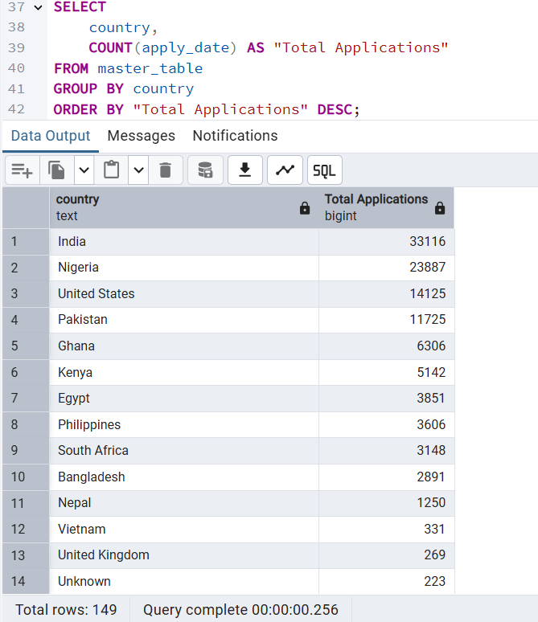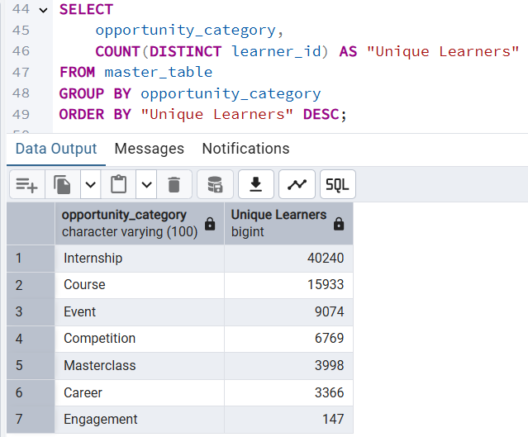

Pie Chart Values (Distribution of Application By Gender) & Donut Chart Values (Status by Email):
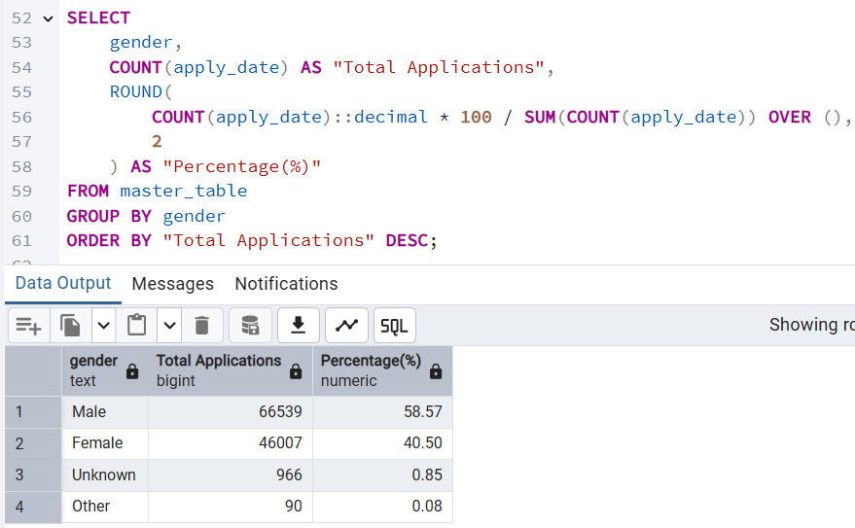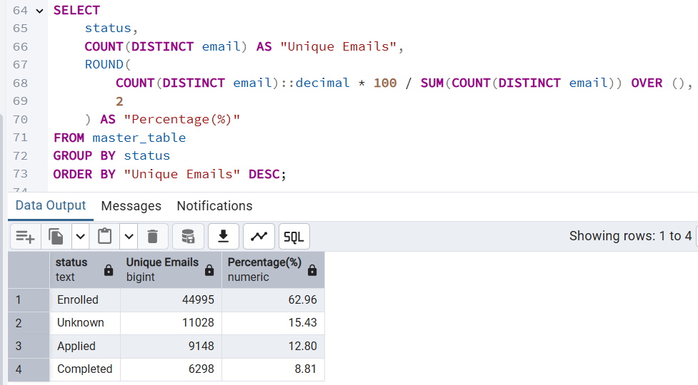
Line Chart Values (Cohort Enrollment Over Time) & Heatmap Chart Values (Enrollment Rate by Country vs. Opportunity Category):

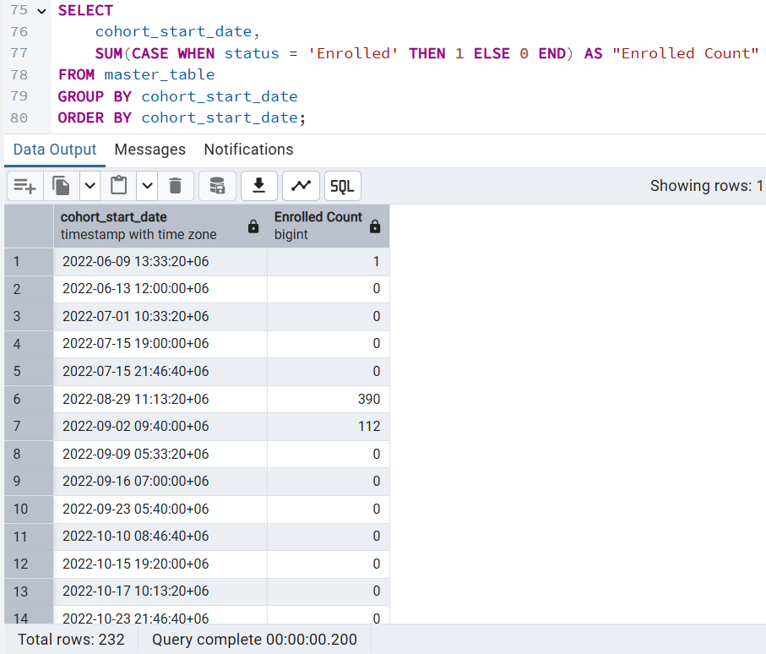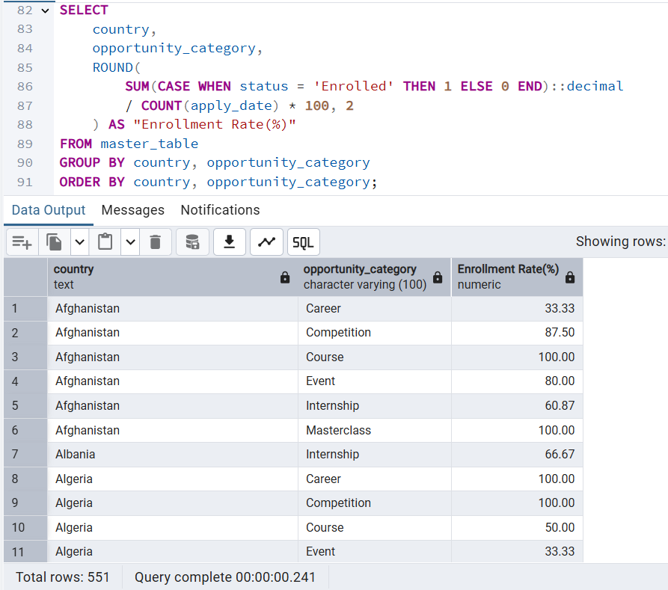

When hovering over any chart in the dashboard, the corresponding values are displayed. These values have been validated by executing queries in PostgreSQL, and the outputs perfectly match the values shown on the dashboard.

Filters: All filters in the dashboard are functioning flawlessly, allowing users to refine data effectively by selecting or unselecting options.
Drill-Down Control: The drill-down functionality operates seamlessly, enabling users to explore data hierarchies and gain deeper insights with ease.
Layout, Colors, and Fonts: The dashboard’s layout, color scheme, and font choices are visually appealing and well-structured, ensuring clarity and enhancing overall user experience. The design maintains consistency and readability across all views, supporting intuitive navigation and interpretation of the data.
Data Accuracy: In PostgreSQL, all relevant queries were executed to validate the metrics, and the results obtained from the database perfectly matched the values displayed on the dashboard. No discrepancies or errors were observed. The dashboard accurately reflects the underlying data and is fully visual, ensuring reliable insights for users.

Dashboard Viewpoint: The dashboard is fully responsive and adapts seamlessly across different devices, including desktops, tablets, and mobile phones. All elements—charts, tables, filters, and text—fit perfectly within the frame, maintaining clarity and visual consistency. The layout, colors, and fonts remain well-structured, ensuring an optimal user experience on any screen size.

Conclusion
In Week 4, the team focused on turning the completed dashboard into meaningful insights and a clear presentation for senior management. The dashboard was refined to be easy to use, visually appealing, and fully interactive, with all filters and drill-downs working smoothly. It is also fully responsive, adapting seamlessly across desktops, tablets, and mobile devices, while maintaining clarity, visual consistency, and a well-structured layout, colors, and fonts.
By analyzing key metrics like applications, enrollment trends, learner demographics, and many more - the team uncovered important patterns and trends that can guide decision-making. All data was carefully checked in PostgreSQL to ensure it matched perfectly with what’s shown on the dashboard, guaranteeing accuracy and reliability.
The final outputs—a polished dashboard, a detailed report, and a professional slide deck—showcase the team’s ability to not just present data, but to tell a story with it. Overall, the project demonstrates how clear visualization and analysis can turn raw data into actionable insights.

